Online Shopping Cart
Nicholas Christensen
Colorado State University Global
CSC500: Principles of Programming
Prof. Steven Evans
6/7/2026
Online Shopping Cart
This program is the Week 4 milestone of the Online Shopping Cart portfolio project. It introduces a custom class, ItemToPurchase, that stores an item's name, price, and quantity, and provides a method, print_item_cost, that prints the item line in the assignment’s required format. The main program prompts the user for two items, instantiates two ItemToPurchase objects, calculates the combined cost, and prints a TOTAL COST summary. The program is written in Python (version 3.14) and was developed in Visual Studio Code.
Pseudocode
START
DISPLAY "Online Shopping Cart"
DEFINE class ItemToPurchase WITH item_name, item_price, item_quantity
DEFINE method print_item_cost TO output "name quantity @ $price = $total"
PROMPT user for item 1 name, price, and quantity
CREATE itemOne AS ItemToPurchase using the entered values
PROMPT user for item 2 name, price, and quantity
CREATE itemTwo AS ItemToPurchase using the entered values
COMPUTE total = (itemOne.price * itemOne.quantity) + (itemTwo.price * itemTwo.quantity)
DISPLAY "TOTAL COST"
CALL itemOne.print_item_cost()
CALL itemTwo.print_item_cost()
DISPLAY "Total: $" + total
END
Source Code
# CSC500 - CT4: Online Shopping Cart (Portfolio Milestone, Week 4)
# ItemToPurchase class + two-item driver program.
# Python 3.14.5

class ItemToPurchase:
"""Represents a single item that may be added to a shopping cart."""

def __init__(self, item_name="none", item_price=0.0, item_quantity=0):
self.item_name = item_name
self.item_price = item_price
self.item_quantity = item_quantity

def print_item_cost(self):
"""Print the item line in the assignment's required format."""
line_total = self.item_price * self.item_quantity
print(f"{self.item_name} {self.item_quantity} @ "
f"${self.item_price} = ${line_total}")

def prompt_item(label):
"""Prompt the user for one item's data and return a populated object."""
print(f"\nItem {label}")
print("Enter the item name:")
name = input()
print("Enter the item price:")
price = float(input())
print("Enter the item quantity:")
quantity = int(input())
return ItemToPurchase(name, price, quantity)

def main():
print("Online Shopping Cart")
print("--------------------")

item_1 = prompt_item("1")
item_2 = prompt_item("2")

total = (item_1.item_price * item_1.item_quantity) + \
(item_2.item_price * item_2.item_quantity)

print("\nTOTAL COST")
item_1.print_item_cost()
item_2.print_item_cost()
print(f"Total: ${total}")

if __name__ == "__main__":
main()
Screenshots
Figure 1
ItemToPurchase source code in Visual Studio Code.
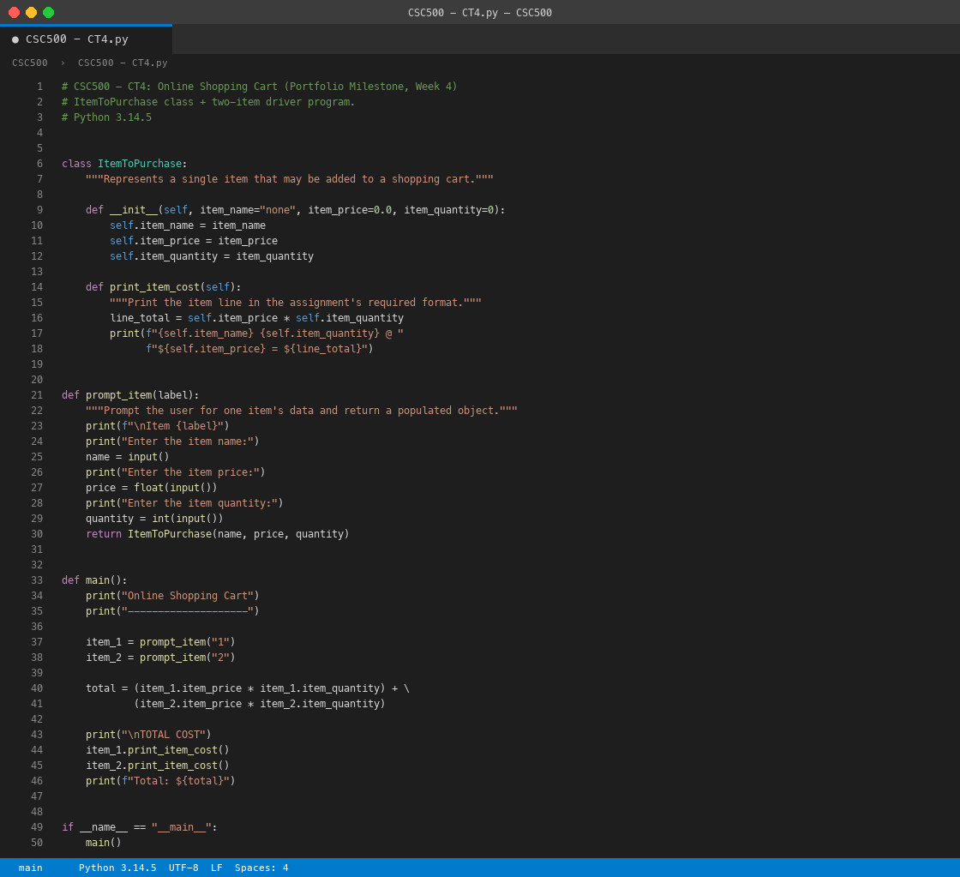

Figure 2
Program output in the terminal showing the TOTAL COST.
